Data Element - Data Element defines the data type, structure component, field labels, search help, etc.

There are two types in which data element is describe - 1. Elementary Type, and 2. Reference Type.

Elementary type is define by the built-in data type, field length and decimal places.

Reference type defines the type of reference variable in ABAP program.

Data Element is used for defining -

1. Data Type

2. Field Label

3. Search Help

A data element describes either an elementary type or a reference type.

An elementary type is defined by the built-in data type, length and possibly the number of decimal places. These type attributes can either be defined directly in the data element or copied from a domain.

1. In the initial screen of the ABAP Dictionary, select object type Data type, enter the data element name and choose Create.

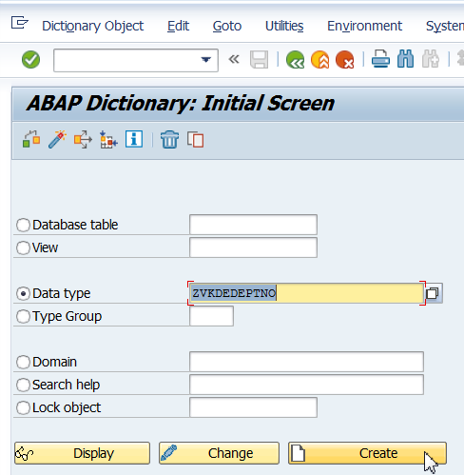

2. A dialog box appears. Select the data element and choose.

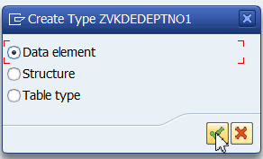

3. The maintenance screen for data elements appears.

Enter an explanatory short text in the field Short text.

The short text appears as title in the F1 help for all the screen fields referring to this data element.

On the Data type tab page, define the data type, number of places and possibly the number of decimal places of the data element. You can define these attributes by specifying a domain or by direct type entry.

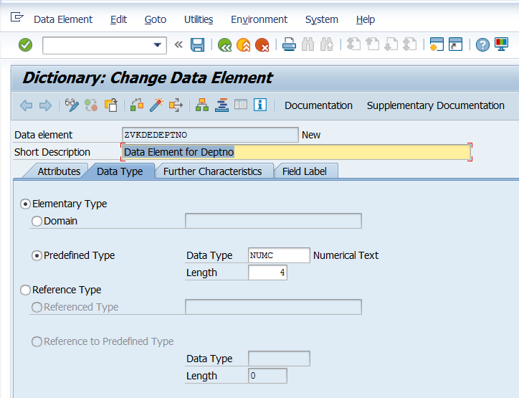

3. Enter Field label. Save and activate the Data Element.

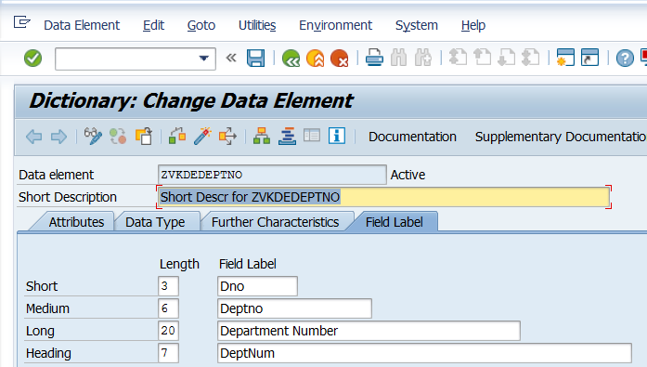

Save

Specify the Field Label

Activate